EXPERIMENT 1:Use Figma to create an interactive diagram illustrating the components of a basic cellular system.
Aim
To create an interactive cellular network diagram in Figma navigating between overview blocks and full component details.
Procedure
- Insert Frame: Create a desktop frame named Desktop 1.
- Draw Blocks: Draw four vertical rectangular cards on the left.
- Add Acronyms: Label them MS, BTS, BSC, and MSC.
- Create Button: Draw a circular VIEW DETAILS button on the right.
- Duplicate Frame: Duplicate it and name the new frame Desktop details.
- Expand Cards: Resize cards into wider horizontal boxes.
- Add Content: Insert full component names and functional descriptions.
- Draw Links: Add vertical connecting lines between the cards.
- Link Frames: Connect the VIEW DETAILS button to Desktop details in Prototype mode.
10.Test Flow: Set to On click right arrow Smart Animate and click Present.
Design:
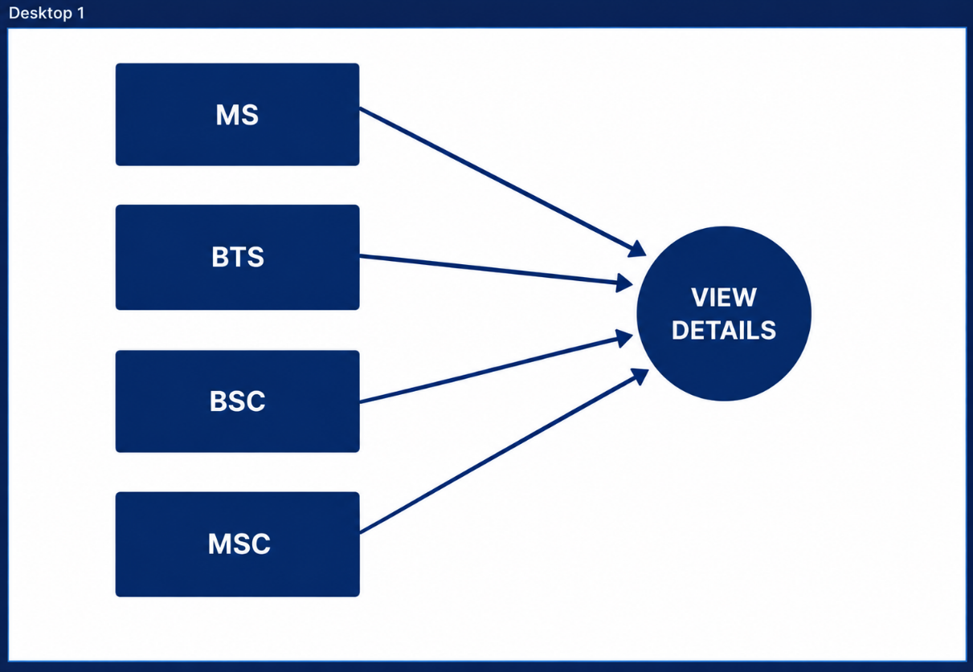

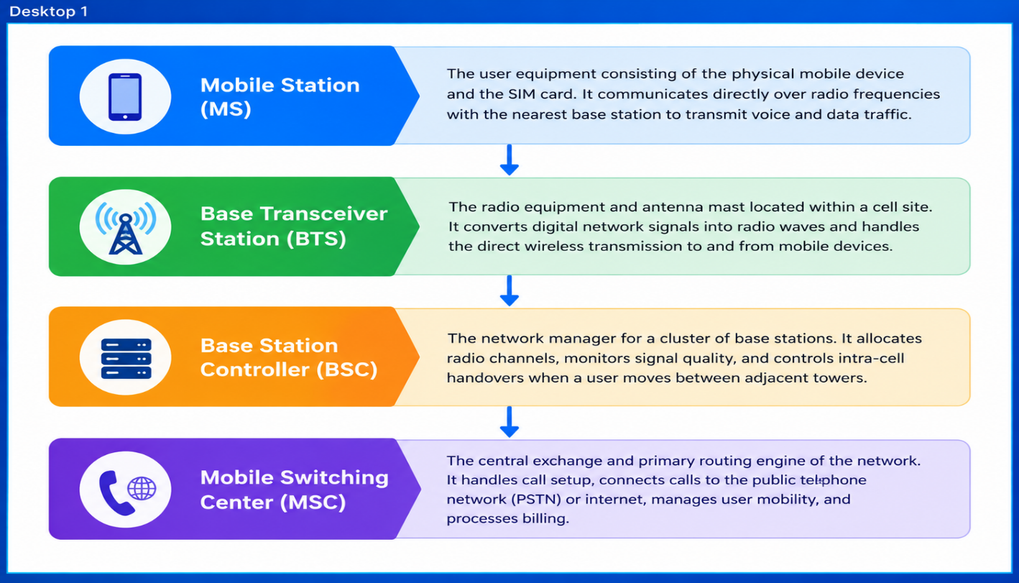Prototype:
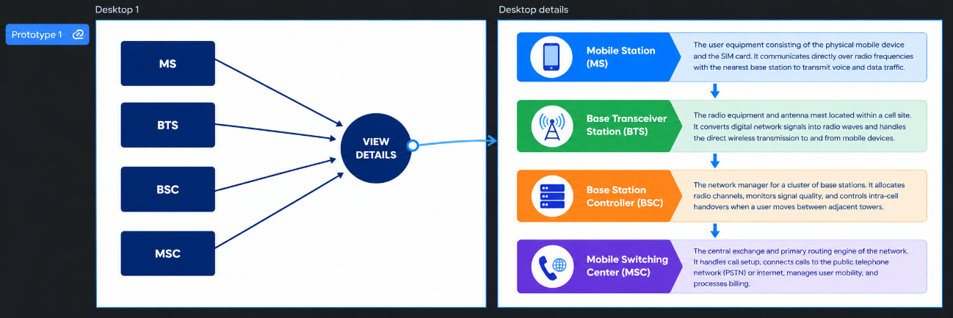

Result
The interactive diagram representing the basic cellular system architecture was successfully designed and prototyped using Figma, enabling smooth interactive navigation from high-level acronym blocks to detailed component specifications.

